***Steps for set up the CarsSystemConsoleApp to run every day via Task Scheduler***

**Step 1:** Click Start Menu, search for Task Scheduler and open it.

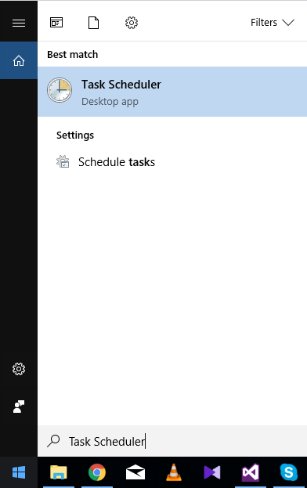

**Step 2:** Click on “Task Scheduler Library folder”, in the left. All of the currently created tasks should be in the first window in the right. Click “Create Basic Task…”

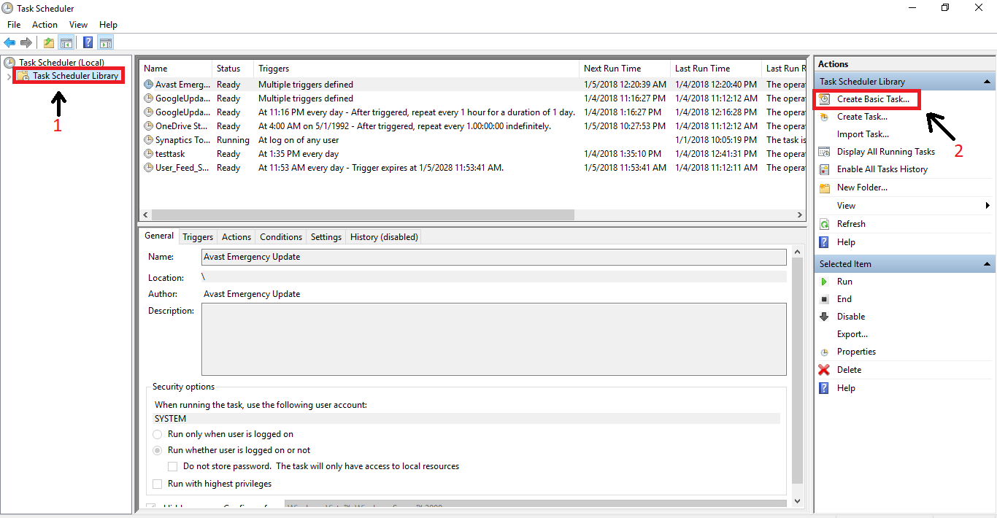

**Step 3:** Popups window - Create Basic Task Wizard. Add name and description for the task. Click Next button.

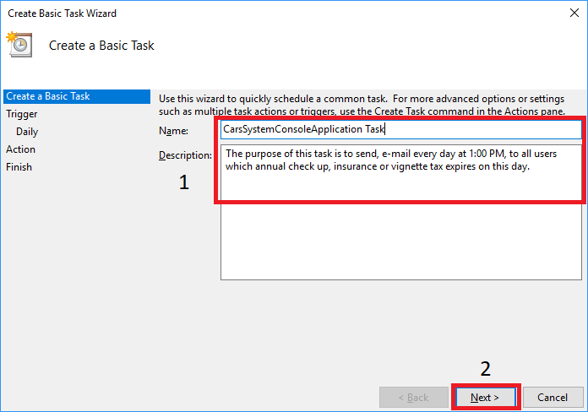

**Step 4:** Choose when do you want to the task to run. We are choosing “Daily” optin. Click Next button.

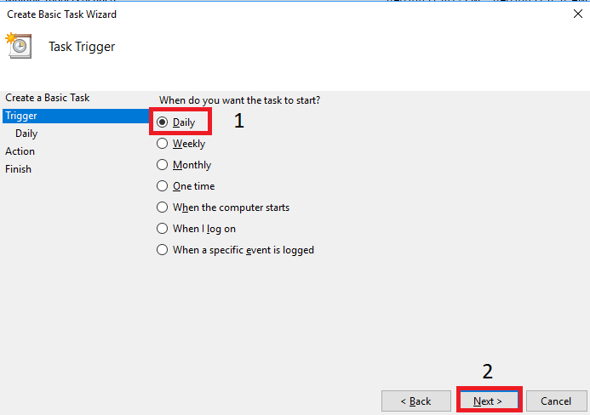

**Step 4:** Set up the start time of the task to 1:00 PM. Click Next button.

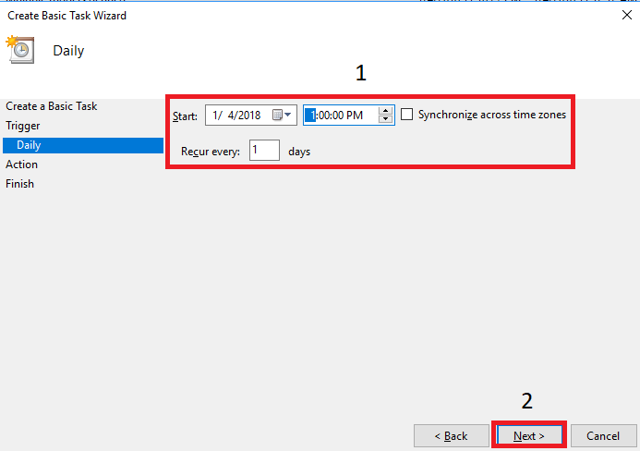

**Step 5:** Choose “Start a program” action and click Next button.

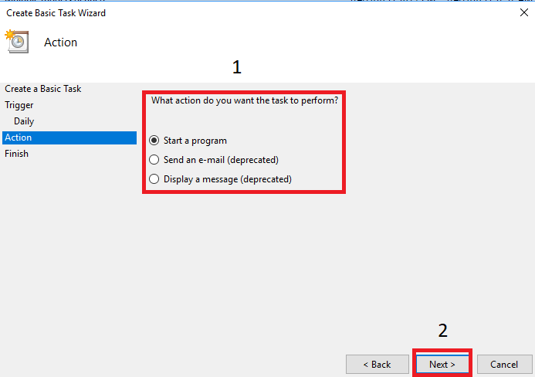

**Step 6:** Browse the path to the ***CarsSystemConsoleApp*** exe and click Next button.

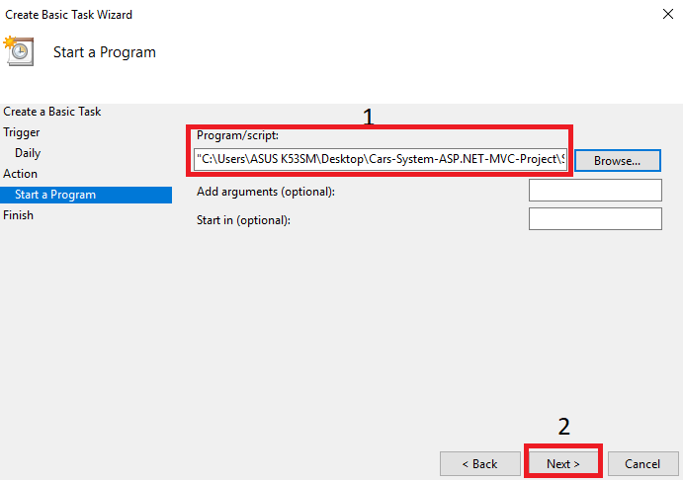

**Step 7:** Click the Finish button. Task with name “CarsSystemConsoleApplication Task” should be created. It will be executed every day at 1:00 PM.

